Internet Usage Policy
In order to view the acceptance code, Security Macros must be enabled. Macro help section and instructions can be identified on page 2.

How to Enable Macros
Microsoft Word Macros can be enabled by performing the following steps:

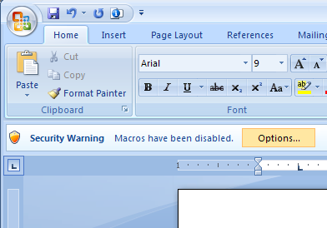
Microsoft Word 2007:
1. If you receive a “Security Warning" stating that “Macros have been disabled”, click Options…:

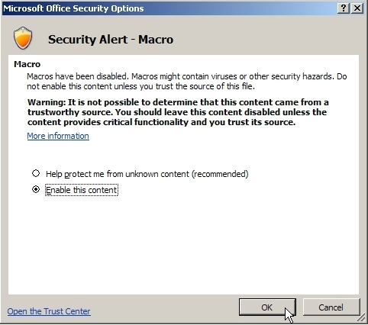
2. Click “Enable this content” and then click “OK”:
1. Click “Options” button

2. Highlight “Enable this Content” then click “OK”

Microsoft Word 2003:
- On the Tools menu, click Options and then click Macro Security.
- On the Security Level tab, click to select Medium and then click OK.
- On the File menu, click Exit to quit Microsoft Word.
NOTE for Word 2003: Though there is no warning message telling you to restart. You must quit and restart Microsoft Word for the security level change to take effect

